Employee Survey Template Questions
Please take a moment to complete this survey related to your child care needs. [Company Name] understands the importance of child care access for a strong workforce and we are gathering data about the child care needs of current employees. Your responses are anonymous.

Section 1. Child Care Needs

1. Do you currently have children in your household who need, or are enrolled in, child care?

Y
N
Prefer Not to Respond

2. How many children do you currently have that need child care? This may also include licensed child care programs such as before and after school care, preschool, and summer day camps.

0
1
2
3
4
5 or More

Branching:
If 0, Skip to: End
Else,

3. Please enter the number of children in your household in each age range:
Fill in the blank:
0-3: _______
3-5: ________
6+:_______

4. How many days a week do you need child care?

1
2
3
4
5
6
7

5. What hours do you typically need child care?

Select All that Apply: 1am, 2am, 3am, 4am, 5am, 6am, 7am, 8am, 9am, 10am…………

6. Have you, or a member of your household, ever missed work due to a lack of child care? (You can answer for any position you have held at this or another company)
Yes
No

7. Have you, or a member of your household, ever had to change positions at work or leave employment due to a lack of available child care? (You can answer for any position you have held at this or another company)
Yes
No

9. If you, or a member of your household, are currently enrolled with a child care provider, what is the current commute time to that child care provider in minutes?

10. If your household is currently enrolled with a child care provider, how much do you spend on child care in a typical month?

Section 2. Child Care Affordability options

Tri Share: The MI Tri-Share Child Care Program can assist qualifying employees with child care expenses with an income above 200% and below 325% of the federal poverty level. Through the program, child care expenses are shared by the employer, the employee, and the State of Michigan, with each contributing one-third of the cost of child care.

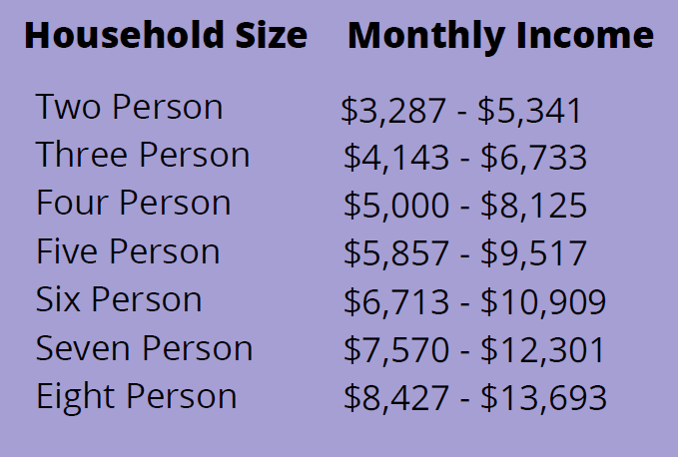
1. This chart displays the income guidelines for Tri-Share according to your household size and your household gross monthly income. Does your monthly household income appear to meet the above income guidelines for Tri-Share? Household income is the total income before taxes for all contributing members of the household. Household size is the number of adults and children that you are responsible for living in your home.
Yes (if yes, continue to Q2)
No- Above the range (Q3)
No-Below the range (Q3)
Prefer Not to Respond (Q3)
2. If your employer were to offer Tri-Share, would you be interested in participating?

Yes
No
Prefer Not to Respond
Other: _________________

3. If your employer were to offer a different program focused on making child care more affordable, would you be interested in participating?

Yes
No
Prefer Not to Respond

